Ideation Phase
Brainstorm & Idea Prioritization Template

Date | 30 September 2026
Team ID | MKU201Team66ab4dee00fc666a751b56cd7
Project Name | Script-Controlled ACL – Restrict Record Access Based on Field Value
Maximum Marks | 4 Marks

Brainstorm & Idea Prioritization Template:
Brainstorming provides a free and open environment that encourages everyone within a team to participate in the creative thinking process that leads to problem solving. Prioritizing volume over value, out-of-the-box ideas are welcome and built upon, and all participants are encouraged to collaborate, helping each other develop a rich amount of creative solutions.
Use this template in your own brainstorming sessions so your team can unleash their imagination and start shaping concepts even if you're not sitting in the same room.
Reference: https://www.mural.co/templates/brainstorm-and-idea-prioritization
Step-1: Team Gathering, Collaboration and Select the Problem Statement
Before you collaborate (10 minutes)
A little bit of preparation goes a long way with this session. Here is what was done before starting.
A. Team gathering
Team members who participated in the session: Amirthavishnu, Gopi, Jeevanantham, Manoj kumar and Desiyan.
B. Set the goal
Focus on solving how record-level access can be restricted using a script-controlled ACL in ServiceNow.
C. Learn how to use the facilitation tools
Use the facilitation superpowers to run a happy and productive session.

Define your problem statement (5 minutes)
What problem are you trying to solve? Frame your problem as a How Might We statement. This will be the focus of your brainstorm.

PROBLEM
How might we restrict users from viewing records unless they meet specific conditions, so that only EEE branch users can view EEE records while administrators retain full access?

Key rules of brainstorming
To run a smooth and productive session
Stay in topic. Encourage wild ideas.
Defer judgment. Listen to others.
Go for volume. If possible, be visual.

Step-2: Brainstorm, Idea Listing and Grouping
Brainstorm (10 minutes)
Write down any ideas that come to mind that address your problem statement.

Amirthavishnu | Gopi | Jeevanantham | Manoj kumar | Desiyan
Create a test user (EEE User) | Custom roles bb1–bb4 | Impersonate EEE user to test | Custom table u_institution_details | Data condition: Branch is EEE
Read ACL on the table | Separate ACL per operation | Verify admin sees all records | Branch choice field (ECE, EEE, CSE) | Elevate security_admin role
Script using gs.hasRole | Assign roles to the user | Test user without any role | Add sample records per branch | Restrict on Service Portal too

Group ideas (20 minutes)
Take turns sharing your ideas while clustering similar or related notes as you go. In the last 10 minutes, give each cluster a sentence-like label. If a cluster is bigger than six sticky notes, try and see if you can break it up into smaller sub-groups.

Users & Roles  • Create test user (EEE User)  • Custom roles bb1–bb4  • Assign roles to the user | Table Design  • Custom table u_institution_details  • Branch choice field (ECE, EEE, CSE)  • Sample records per branch
ACL Rules (Read, Create, Write, Delete)  • Read ACL with Branch is EEE condition  • Script using gs.hasRole  • Separate ACL for each operation  • Elevate security_admin role | Testing & Verification  • Impersonate EEE user  • Impersonate admin  • User without role sees nothing  • Service Portal restriction

Step-3: Idea Prioritization
Prioritize (20 minutes)
Your team should all be on the same page about what’s important moving forward. Place your ideas on this grid to determine which ideas are important and which are feasible.
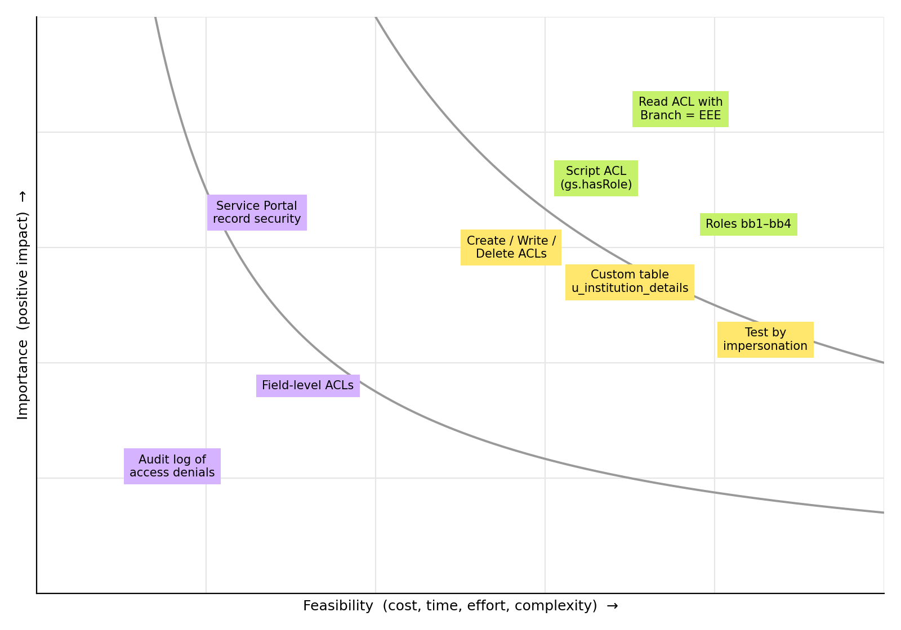
Importance – If each of these tasks could get done without any difficulty or cost, which would have the most positive impact?
Feasibility – Regardless of their importance, which tasks are more feasible than others? (Cost, time, effort, complexity, etc.)

